After landing in SF, I had lunch in the Terminal 3 food court before heading to Terminal G and watched planes. I went to the outdoor terrace. With the weather this morning, I would be considered crazy for going out there. It was indeed a little wet but not a problem.

She got towed in twenty minutes prior to this picture… I grabbed a pic of her as I was planespotting in the outdoor terrace.

Somehow, I got Group 1 boarding… I did not argue, and I had to confirm that I was fine sitting in an exit row seat when my boarding pass was scanned. My Chinese Visa and my Passport was checked as I was boarding.

I grabbed a picture of the rear Polaris (Business Class) and Premium Plus (Premium Economy) cabin. Earlier this year when I flew to Frankfurt this cabin was still E+, and it still is on some routes (ORD-PVG if you catch one of the new planes).

Legroom… unlimited. It’s 34” pitch on the other seats per the website. Width is 17.25” for exit row (I don’t know why the website says 17.05”) and it’s probably the same for other seats. Recline is 5” and the seat panned forwards an inch (I didn’t pay attention to if it cradled or not, but I felt it did). And armrest width is 1.75” (tad bit less on my side armrest). To the accuracy of the measuring tape (except the 34” part).

A Flight Attendant came out and talked to me about the exit row responsibilities in Chinese. I spoke that language, so it was fine, but we chatted in English.

He asked me not to divulge into our conversation but did give me a gift. Many thanks to him! Unfortunately, he will serve the other side (in a bit).

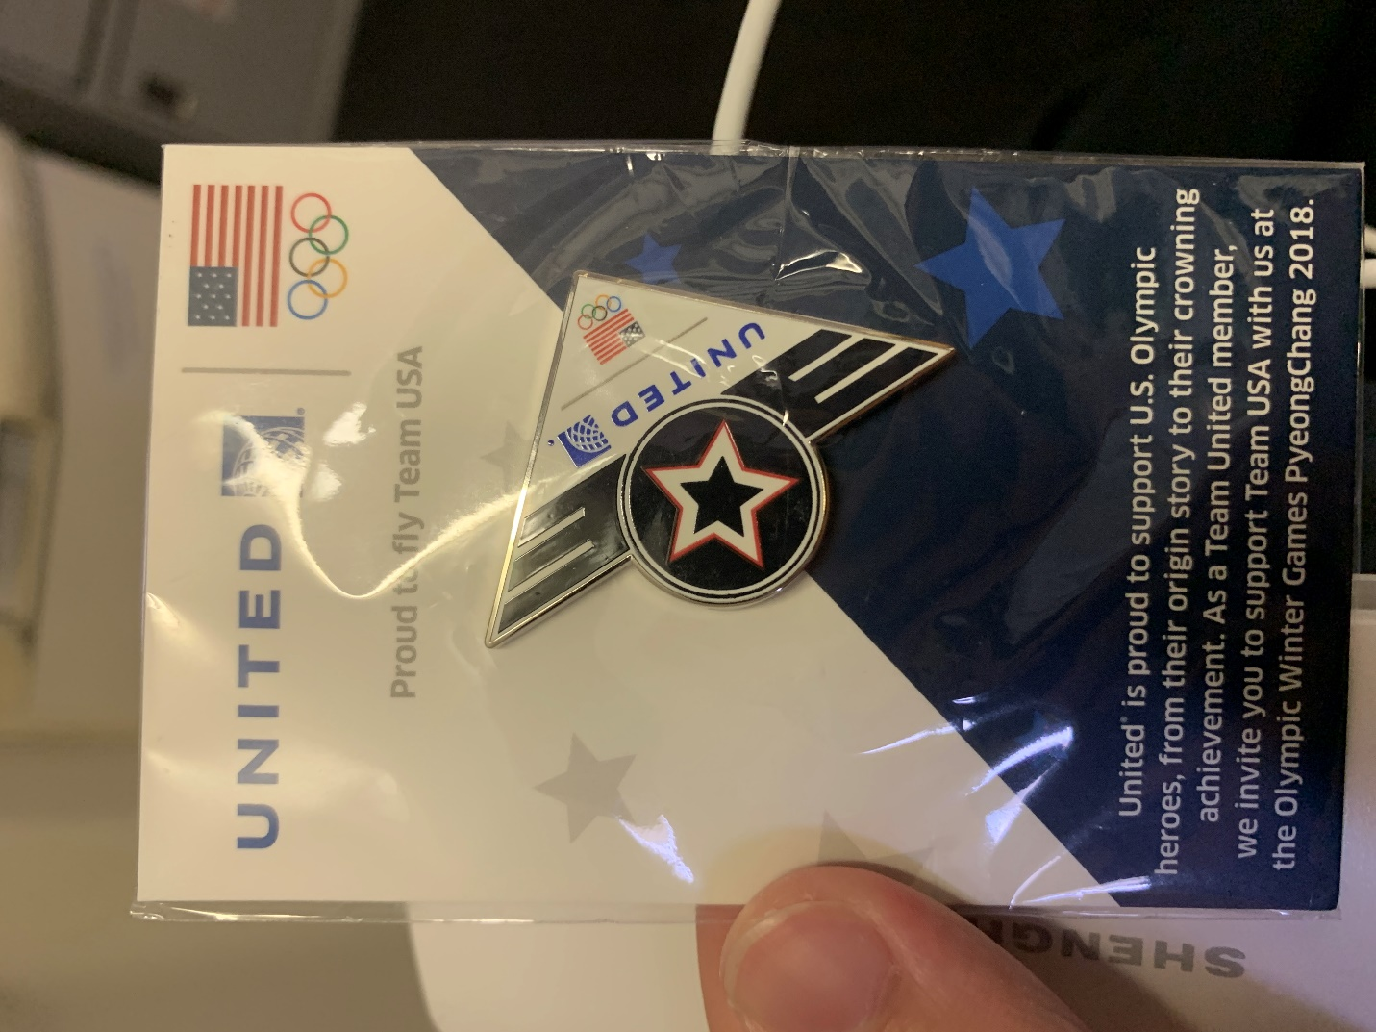

We left the gate ten minutes late to wait on some connecting passengers (thanks to United’s Connection Saver). Yet we would still be put into Shanghai about 20 minutes early.

The two very powerful PW4090 engines were started after we were pushed back and pulled to the edge. Then it was a quick taxi to Runway 28R…

And a turn-and-burn takeoff.

But not before seeing some other jets. Unfortunately, I used my iPhone to video as I had an exit row so… they’re pretty unclear.

After takeoff a snack was served. It was… enough. Full can of drinks were handed out… I’m not arguing except for the fact that the FA serving drinks on my side did not smile and I did have the feeling, for the first time on flying United, of being a nuisance. Is it the SFO based FAs?

I also love Harry Potter. I highly recommend it.

The PTVs were 9.25” for exit row and probably bulkhead. I don’t know why it’s a tad bigger than usual, but I’m not arguing. Of course, the tray table and screens are in the armrests, which effectively means you can’t move the armrests. It was also very dirty when I boarded, so I grabbed some sanitation wipes and cleaned it up.

“Lunch” was served an hour and ten minutes into the flight… I use air quotes because it is now almost 4:00pm PST. But the size of the meal does not fit “snack” because it is too big, so… The choices were two “equally good Chicken with Rice or Veggie Fried Noodles” (the FA’s words, not mine). We were asked to share coffee preferences first and asked to keep stuff away from the aisle.

When I saw the meal, my reaction was surprise at seeing real salad! The FA was also surprised and said, “yes, very good.” Ok, so not sure what to say but… I think Gategourmet catered the meals. Real Salad is always delicious. With the right dressing, it makes it even better. Remember to puncture the liquids lid first before opening or else it might cause a mess! Nothing can be said about the bread. It’s standard. That’s all you need to know. The Chicken and Rice was kind of bland until I added some salt. It made the Chicken and Rice very delicious! Though not everyone did that.

I had a Ginger Ale. The same service (cold, unwelcoming, full can) I got in the drink service was received. I guess I can’t argue when full cans are handed out. A picture containing cup, coffee, table, indoor

I like it when Gelato is served. Quit it with the “sorbet” and just pass out Vanilla Gelato or Vanilla Ice Cream. It’s a fan favorite, everyone likes it, and no one will argue when Ice Cream is passed out. Or Chocolate Ice Cream/Gelato. Both are favs. Water was passed out as well. No tea/coffee service.

The fat content of the Gelato makes it creamy and I thoroughly enjoyed it.

Trash was picked up afterward.

I walked around the cabin a few times for the pictures.

Six hours in, another “meal” was “served”. It was tossed out instead of being politely handed out. I guess I should be glad lights were not turned on for this meal service? You can see why I used air quotes.

One hour and a half out, the pre-arrival meal was served. Something most airlines mess up or skip. How will it be?

It’s actually good! I had the omelet and potatoes and it was delicious.

My seatmate reported that the French Toast was delicious as well. I skipped the fruit though. It looked just as fresh as that sandwich passed out earlier.

We landed at night… it was very dark, and we had an on-time arrival. Once I landed, I was through baggage claim and border formalities (Immigration and Customs) within the hour.

The service on the flight was a mixed bag. The gentleman that checked with me about the exit row seating was a gem. The same could not be considered for most of the others… they just did the job and did not welcome us as much.